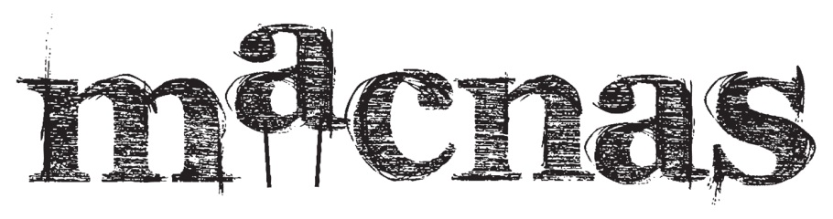
Macnas (noun)
The frolicking behavior of a young calf let out to grass for the first time after being kept inside all winter- joyful abandonment, dalliance and wantonness.
An award winning internationally acclaimed company who specialize in creating extraordinary interactive spectacle theatre globally.

Macnas Seeks a New General Manager!
Macnas seeks to employ a dynamic and ambitious individual as General Manager to work alongside Artistic Director Noeline Kavanagh through an exciting period of growth and change for the company. With a growing roster of national and international presentations, Macnas is also working towards producing one of the anchor events of Galway 2020, Europe’s Capital of Culture. Our ideal candidate will have at least three years experience in an arts management role, with the ability to work across multiple projects and productions, supporting the ambition and rigour of Macnas’ large scale programming with good humour and grit. Our new General Manager will be a highly motivated and entrepreneurial person, who will have responsibility for the finance, operations, marketing and brand management of the company, working to facilitate and deliver the vision of Macnas alongside the Artistic Director. The unique work of Macnas brings the company to work with all kinds of people in unusual locations, and our new General Manager will need to be confident working in a warehouse or building workshop environment, at outdoor festival sites, boardrooms and conferences as well as in our home in Fisheries Field.
This is a full-time position, reporting to the Artistic Director and the Finance Committee of the Board, and the company will offer a two-year contract to start, with a probationary period of six months. To apply, please send a detailed letter of application of no more than three pages, demonstrating how your experience meets the key requirements of this role, alongside your CV by Friday 9 December by email to admin@macnas.com. Interviews will be held in Galway on 15 and 16 December. We envisage that our selected candidate will take up the role in February/March.

Key Responsibilities include the following:

Strategy and Development
- Support the strategic development of Macnas in a short, medium and long-term in collaboration with the Artistic Director. This includes new productions, touring, and partnership development, securing funding and identifying new sources of income.
- Assist in the creation and submission of funding applications in association with the Artistic Director whilst maintaining positive relationships with key stakeholders e.g. Arts Council, Galway City Council, Culture Ireland, NUIG.
- Prepare annual budgets for programme and core administration needs; monitoring these budgets on a day-to-day basis, particularly in peak production time.
- Support the Artistic Director to maximize the earning potential of the company; creating national and international touring opportunities with the current repertoire of work.
- Support the Artistic Director to build new networks and partnerships to extend the life of productions and create a financially sustainable business model in both a subsidised and commercial environment.

Management and Finance
- Prepare and manage company’s annual budget.
- Work in conjunction with the auditor to prepare the annual audited accounts.
- Direct and oversee the work of the company book-keeper including the presentation of newly introduced monthly management accounts.
- Analyse annual programme’s financial needs including cash flow and construct the overall (and individual) budget(s) accordingly in conjunction with the Artistic Director.
- Rigorously monitor the agreed budget(s) to limit the potential of overspend and adjust budgets accordingly.
- Negotiate all financial contracts, performance fees and dates with a range of diverse presenters including festivals and venues nationally and internationally.
- Negotiate all contracts with artistic and production personnel based on agreed budget resources, taking cognisance of best practice in this respect.
- Ensure all the appropriate insurance is in place in line with best practice (public liability, employers, directors and travel).
- Agree with the Artistic Director a list of particular activities to be carried out in each year and ensure that these activities can be met within the Macnas annual budget.
- Support production and programme team during productions, events and tours.
- Arrange and manage all banking and online payments including all invoices for artists/suppliers.
- Manage and control overall petty cash system for productions.

Funding
- Assist the Artistic Director to identify new funding opportunities and maintain existing funding sources.
- Compile budgets, financial projections and arguments to support the programme or projects as proposed by the Artistic Director.
- Advise the Artistic Director in relation to deadlines set by funding agencies and support the timely delivery of funding applications.
- Researching deadlines, eligibility criteria of all funding streams to which Macnas could potentially apply (touring and disseminating scheme, philanthropy funds initiatives, capital funds, Culture Ireland, Fáilte Ireland, Public Art Schemes, Young Ensemble Scheme).

Governance
- Liaise with the Board of Directors to ensure statutory obligations are met.
- Convene and produce all documents and minute Board Meetings.
- Develop and review all company policies and ensure legal compliance including health and safety, child protection, equal opportunities.

Human Resources
- Negotiate, issue and manage all contracts for artists, performers, and creative team, stage management and production personnel.
- Conduct staff performance evaluations for consideration by the board.
- Ensure that the working environment is suitable as far as possible for the needs of the employees and the working artists.
- Ensuring adequate security is in place for the workplace in Fisheries Field and Liosbaun.
- Supervise all part-time and casual administrative staff and look after staff welfare.

Communications and Brand Management
- Represent Macnas at key national and international events
- Website: Oversee the management of the Macnas Website on an ongoing basis under the direction of the Artistic Director.
- Oversee P.R, and Marketing concepts for sign off by the Artistic Director.
- Work to ensure that the Macnas Brand and profile is represented strongly online and in broadcast and print media.
- Continue to grow the online community of supporters via all social media channels.

Person Specification Essential:
- At least three years in a demanding arts management role
- Experience of Microsoft Word, Excel, and standard CMS systems
- Experience of creating and managing detailed production budgets
- Experience of managing a team in the delivery of complex arts events at a large scale.
- Experience of negotiating contracts with festivals and venues, artists and suppliers
- Experience of the flexibility required to work directly with artists as well as executives – our GM must be comfortable wearing wellies as well as a business suit.

Person Specification – Desirable
- Experience of producing large scale street arts and spectacle
- Experience of international touring
- Experience of industry networking at a European level
- Experience of negotiating contracts with international festivals and agents
- The ability to multi-task – working on projects at hand while planning for the long-term vision and artistic ambitions of Macnas.
- Possession of a can-do attitude and an entrepreneurial spirit – Macnas not only dreams big but achieves big, and seeks a General Manager with the same spirit.

Terms and conditions of Employment:
This role is offered on a full-time basis, starting with a two-year contract, inclusive of a six-month probationary period, working from Macnas’ premises in Fisheries Field, NUIG Campus, Galway. The General Manager will report to the Artistic Director (CEO) and to the finance and audit sub-committee of the Board of Directors. The position will be remunerated at a salary within the range: €37,000 - €40,000 commensurate with experience.
